Software Requirements Specification

for

Automated Software Engineering Student Subject Evaluations (ASESSE)

Version 1.0

Prepared by Tanaka Madyara, Deepthi Ummala, Samuel Weems



September 21, 2018

Table of Contents

Table of Contents 2

1. Introduction 1

1.1. Purpose 1

1.2. Scope of Project 1

1.2.1. Main Objective 1

1.2.2. Specific Goals 1

1.3. Overview of Document 1

2. Users 2

2.1. Who are Users? 2

2.2. Use Cases 2

2.3. Use Case Diagram 4

2.4. Use Case Senarios 4

3. System 7

3.1. Development Environment & Target Environment 7

3.2. Target Environment 7

3.3. Functional Requirements 7

3.3.1. Issues 7

3.3.2. Major Subsystems 7

3.3.3. Major Functions 8

3.3.4. Major Classes 8

3.3.5. Minor System Functions 8

3.4. User Interface Specifications 9

3.5. Non-Functional Requirements 16

3.5.1. Management 16

3.5.2. Technical 16

3.5.3. Performance 17

3.5.4. Security 17

3.6. System Evolution and Maintenance 17

4. Other Deliverables Required 17

5. Risks 17

Appendix A: Glossary 18

Appendix B: References 18

# Introduction

## Purpose

The purpose of this document is to provide an official detailed description of the requirements for the “Automated Software Engineering Student Subject Evaluation” (ASESSE) software. This document seeks to fully describe the expected behavior of the software including all high level functions, capabilities and constraints. This document will be used as a proposal to the customer and as a reference by the development team.

## Scope of Project

### Main Objective

The “Automated Software Engineering Student Subject Evaluation” (ASESSE) is a web-based application which automates the student peer review system for Software Engineering Students at Midwestern State University located in Wichita Falls, Texas. The main purpose is to allow students to review other students in their course group and to collate that information automatically for the professor.

### Specific Goals

Each student in a group should be able to connect to the website, enter a password specific to their course, and then provide the information requested with regards to their specific group members through a graphical user interface. While the submitting user name and their review of their group members are collected, they will be stored separately and disconnected from one another to maintain anonymity.

The professor, or administrator, should be able to setup new classes with their own specific passwords, change the passwords if needed, delete or clear a class that has been setup, check to see the progress of all students in completing their reviews, request an report for an individual student that aggregates the reviews of that student, and request a course aggregate report which puts all individual student reviews into one printable pdf document.

## Overview of Document

This document is divided into 5 major sections including the introduction to the document, users, system, other required deliverables, and risks. The introduction to the document provides the purpose of this document, the scope of the project and an overview of this document. The user section describes who the users will be, use cases with use case diagrams and various scenarios. The system section provides information regarding the development and target environments as well as the functional and non-functional requirements. The other required deliverables section illuminates any additional requirements of the project and the risk section covers risks related to the development and deployment of the system.

# Users

## Who are Users?

There are two types of users that interact with the system: the professor or administrator of the system, and students. Student users will access the system through a web address that only provides student user functions. Administrators will access the system through a separate password protected web address that will provide access to administrator functions.

## Use Cases

|  |  |  |  |  |
| --- | --- | --- | --- | --- |
| **Use Case ID** | **Use Case Name** | **Primary Actor** | **Implementation Complexity** | **Priority** |
| A | Student Submission | Student | Medium | 1 |
| B | New Course | Administrator | Low | 1 |
| C | Change Course Password | Administrator | Low | 2 |
| D | Remove Course | Administrator | Medium | 3 |
| E | Course Progress | Administrator | Medium | 2 |
| F | Individual Student Report | Administrator | High | 1 |
| G | Course Report | Administrator | High | 1 |

Use Case ID: A

Use Case Name: Student Submission

Primary Actor: Student User

Trigger: Student web address accessed

Pre-Conditions: Login password correct and course selected

Post-Conditions: Display success message and store submitted information in database keeping student name separate from reviews.

Description: Student connects to the web portal, selects their course, and gains access by entering the appropriate password. The student fills out reviews of other students in their group and clicks “Next” to proceed. The student enters their name and “Submit” to complete the process.

Use Case ID: B

Use Case Name: New Course

Primary Actor: Administrator User

Trigger: New Course option selected

Pre-Conditions: Login password correct

Post-Conditions: New course name and password added to database, success message displayed

Description: Administrator connects to web portal, enters password to gain access, and creates a new course with name and password.

Use Case ID: C

Use Case Name: Change Course Password

Primary Actor: Administrator User

Trigger: Change Course Password option selected

Pre-Conditions: Login password correct, course selected

Post-Conditions: New password added to database, success message displayed

Description: Administrator connects to web portal, enters password to gain access, and changes the password for selected course.

Use Case ID: D

Use Case Name: Remove Course

Primary Actor: Administrator User

Trigger: Remove Course option selected

Pre-Conditions: Login password correct, course selected

Post-Conditions: Course name, password, and reviews removed from database

Description: Administrator connects to web portal, enters password to gain access, and removes the course including all stored data.

Use Case ID: E

Use Case Name: Course Progress

Primary Actor: Administrator User

Trigger: Course Progress option selected

Pre-Conditions: Login password correct, course selected

Post-Conditions: Display database information necessary

Description: Administrator connects to web portal, enters password to gain access, requests course progress and system displays report as a list of students who have submitted reviews.

Use Case ID: F

Use Case Name: Individual Student Report

Primary Actor: Administrator User

Trigger: Individual Student Report option selected

Pre-Conditions: Login password correct, course selected, student selected

Post-Conditions: Display database information for selected student in selected course

Description: Administrator connects to web portal, enters password to gain access, requests individual student report and system displays aggregated review of that student.

Use Case ID: G

Use Case Name: Course Report

Primary Actor: Administrator User

Trigger: Course Report option selected

Pre-Conditions: Login password correct, course selected

Post-Conditions: Display database information for selected course, provides pdf file for download

Description: Administrator connects to web portal, enters password to gain access, requests course report and system displays aggregated student reviews for all students and presents option to save data as a pdf file.

## Use Case Diagram



## Use Case Senarios

1. Student submits group evaluation
   1. Student selects course
   2. Student types in course password
   3. Student selects number of group members
   4. Student fills out forms to review other members of their group
   5. Student presses “Next”
   6. Student types in name
   7. Student presses “Submit”
   8. System sends confirmation to screen

Extensions:

2a. Incorrect password

1. System sends error message
2. User returned to initial login screen
3. Administrator creates new course
   1. Administrator types in password
   2. Administrator selects “New Course” option
   3. Administrator inputs course name, password and password confirmation.
   4. System displays success message
   5. Administrator selects “Continue”
   6. Administrator returned to main page
   7. Administrator logs out of system
   8. System displays success message

Extensions:

1a. Incorrect password

1. System sends error message
2. Administrator returned to initial login screen

3a. Course already exists

1. System sends error message
2. Administrator returned to main page

3b. Password fails password requirements

1. System sends error message with password requirements
2. Retry password creation
3. Administrator changes password for a course
   1. Administrator types in password
   2. Administrator selects existing course
   3. Administrator selects “change password” option
   4. Administrator inputs new password and password confirmation
   5. System displays success message
   6. Administrator selects “Continue”
   7. Administrator returned to main page
   8. Administrator logs out of system
   9. System displays success message

Extensions:

1a. Incorrect password

1. System sends error message
2. Administrator returned to initial login screen

4a. Password fails password requirements

1. System sends error message with password requirements
2. Retry password creation
3. Administrator removes a course
   1. Administrator types in password
   2. Administrator selects existing course
   3. Administrator selects “Remove Course” option
   4. System displays “Are you sure?” message
   5. Administrator selects “Yes” option
   6. System displays success message
   7. Administrator selects “Continue”
   8. Administrator returned to main page
   9. Administrator logs out of system
   10. System displays success message

Extensions:

1a. Incorrect password

1. System sends error message
2. Administrator returned to initial login screen

5a. Administrator selects “No” option

1. Administrator returned to main page
2. Administrator checks progress of submitted group reviews
   1. Administrator types in password
   2. Administrator selects existing course
   3. Administrator selects “Check Progress” option
   4. System displays list of names that have submitted reviews
   5. Administrator selects “Return to Home Page”
   6. Administrator returned to main page
   7. Administrator logs out of system
   8. System displays success message

Extensions:

1a. Incorrect password

1. System sends error message
2. Administrator returned to initial login screen
3. Administrator requests individual student aggregate report
   1. Administrator types in password
   2. Administrator selects “Individual Student Report” option
   3. Administrator selects course name
   4. Administrator selects student name
   5. System displays aggregate of reviews submitted for student
   6. Administrator selects “Return to Home Page”
   7. Administrator returned to main page
   8. Administrator logs out of system
   9. System displays success message

Extensions:

1a. Incorrect password

1. System sends error message
2. Administrator returned to initial login screen
3. Administrator requests printable course aggregated report of all students
   1. Administrator types in password
   2. Administrator selects “Course Report” option
   3. Administrator selects existing course
   4. System displays aggregate of reviews submitted for all students
   5. Administrator selects “Save Report”
   6. System provides download dialog box for pdf version
   7. Administrator saves document using dialog box options
   8. Administrator selects “Return to Home Page”
   9. Administrator returned to main page
   10. Administrator logs out of system
   11. System displays success message

Extensions:

1a. Incorrect password

1. System sends error message
2. Administrator returned to initial login screen

# System

## Development Environment & Target Environment

The product will be developed using the text editor Visual Studio Code. This text editor provides the necessary extensions needed to write the code to make a web-based software. The framework used to support the backend of the software is LAMP, or, Linux, Apache, MySQL, and Php, with a Bootstrap framework to support the front end.

## Target Environment

The target environment includes an Apache server whose database is managed by the structured query language, MySQL, which communicates with a Php API, all on a Linux operating system.

The front-end of the target environment, that the users interact with, includes HTML for the basic layout of the web pages, CSS to style the pages, and JavaScript to interact with the pages for the User Interface.

## Functional Requirements

The following functionality will be provided by the system.

### Issues

The prototype will focus on the ensuring that the database is functional. There may be problems with the aggregation of student scores, concatenation of a student’s evaluation comments, and creating the overall course report. This is due to the implementation complexity of adding this functionality to the system

The second phase of the prototype is ensuring that all components of the system work together, debugging, and adding a clean and user-friendly user interface for both the student user as well as the administrator.

### Major Subsystems

User 1: The Student

Login to system:

The system will allow the student user to enter a password provided by the administrator (professor), giving them access to their course.

Fill out evaluation form:

The user will then fill in the required fields for the evaluation and submit the form to the administrator to view.

Submit form:

The system provides a button to submit the form.

User 2: Administrator/Professor

The system gives the professor permissions to create a new course, change the password for that course, remove a course, view the course progress, generate an individual student report for each student given an ID to access that course, and generate an overall course report.

Major Subsystems include the main program container, user login forms for the student user.

### Major Functions

User 1: Student

Student Logs into system, fills out form, submits form

The major object classes include a main program container (HTML), menu page to choose course (FE system), user login (FE system), then a blank form to enter information. When the information has been entered, the user can push a button to submit the form and a message asking to confirm this action appears (modal). Once the action is confirmed by clicking on a confirmation button, the information is submitted to the database.

User 2: Admin

### Major Classes

User 1: Student

Class Student: stores the ID, password, and form data entered by the student

User 2: Admin

Class Admin: allows user name and password to be entered in this data structure

Class courseProg: evaluates the progress of a course’s students

class studReport: compiles all documentation on a student

Class studAggreg: aggregates a score for a student

Class courseReport: allows for course documents to be compiled together

### Minor System Functions

User 2: Admin

setCourse: allows the administrator to set the course number for the current semester

setPW: allows the administrator to set the password to log into the system

setStudPW: allows the administrator to set the password for a specific student

## User Interface Specifications

The purpose of this section of the documentation is to describe how the users will interact with the system. The User will be given access to the software through a web page and will be given options to choose from on the front page.

A screenshot of a cell phone

Description generated with very high confidence

User 1: Student

The student user will have the option of choosing their course. The student will click on their course which reveals the login page for their course.

A screenshot of a cell phone

Description generated with very high confidence

After entering the correct username and password provided by the administrator, the student user will fill the ASESSE form.

A screenshot of a cell phone

Description generated with very high confidence

Upon completion of the form, the student user must click on the “submit” button to deliver their evaluation to the administrator. The student will be asked to confirm that they have completed the evaluation and must be sure to submit it. (The name of the student they are evaluating must be entered also). After submission confirmation, the student user will be asked to evaluate another student until they have completed their evaluations.

User 2: Administrator

The administrator user will be taken to an administrative home page after they have entered the correct information to access the administration section of the system.

A screenshot of a cell phone

Description generated with very high confidence

As an administrator, there are options to create a course, remove a course, view course progress, view an individual student’s report, as well as view an overall course report.

When the administrator selects to create a course, a modal will appear and allow them to create a course for students to evaluate. The administrative user must enter a course name, course number and the number of students in the course (class size).

A screenshot of a cell phone

Description generated with high confidence

When the administrative user wants to remove a course from the system, they have the option to choose which class to remove from the list of courses present. A cautionary message will appear when the “submit” button has be clicked on to ensure that this is the action they want to take. Upon submission, the course is removed from the system, but all data collected from the course will still exist in the database.

A screenshot of a cell phone

Description generated with high confidence

The administrative user has the option to view course progress. This option allows the user to view the evaluations that have been submitted by the students in that course. The administrative user has the option to view the Individual Student Reports of the student whose name they click on. The return button takes them back to the administrator home page.

A screenshot of a cell phone

Description generated with very high confidence

The administrative user has the option to view the individual student report and system displays aggregated review of that student. Upon clicking the return button, the administrative user is returned to the course progress page.

A screenshot of a cell phone

Description generated with very high confidence

Administrative user has the option to generate a course report comprised of all students in the class and system displays aggregated student reviews for all students and presents option to save data as a pdf file once a course has been selected.

A screenshot of a cell phone

Description generated with very high confidence

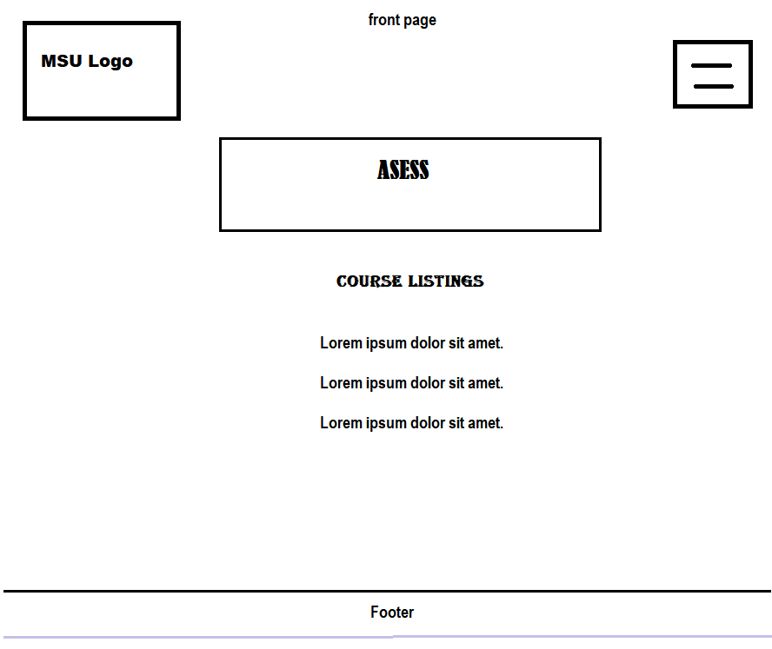

## Non-Functional Requirements

### Management

Due to this being a student-developed project, there will be no cost incurred on our part. Project must be developed during the Fall semester and completed by December 2018. Periodic reviews and testing of the listed functions should be conducted to ensure that the project meets the requirements. This includes verifying the database every time while submitting each review.

### Technical

This project must run inside the web browser that is accessed over the network connection, rather than existing within a device memory. Likewise, the development environment will also be Windows 7 or Later version and it is to be written in some java development environment. Based on the customer requirement PDF format of each student review will be downloaded to the user’s desktop.

### Performance

Efficiency and reliability are not the major concerns for this project. However, the race participants or the students should be able to understand the application and utilize the application throughout the race. The project should also be user-friendly, in that it needs to be understand and impressed by the customer or the administrator .

### Security

The customer has requested that the completed project contains a standard password access to the administrator to login into the application and change or modify the databases and create new courses and password access for each course.

## System Evolution and Maintenance

As software system failure is predictable we can avoid those by Software Maintenance. As this is a semester project, Maintenance cannot be done after delivery. So before delivery of project we perform all the testing perfectly so that rate of failure could be low. Goal of the project is reached by developing application with best solutions possible.

# Other Deliverables Required

At the end of October 2018, a project plan, requirements specification document, and test plan will be delivered to the administrator. At the end of November 2018, an updated specification documents, user manual and all the packages of the project will be delivered to the administrator. This project also requires documentation for transporting the software from the current test server utilized by students (cs2 server) to the public server for the computer science department (cs1 server).

# Risks

Risks during the development of this project might happen due to lack of communication between the team members. Project risk includes illness of team members, change in requirements, no experience of working on HTML and JavaScript. It also includes that when the web browser or server is not connected to the network connection.

Appendix A: Glossary

ASESSE - **A**utomated **S**oftware **E**ngineering **S**tudent **S**ubject **E**valuations

Peer Review - Evaluation of the academic work by the administrator in the same field.

User - Someone who interacts with the web-based application

Administrator - A professor who is given specific permission for managing and controlling the application

User Interface - Interaction between the user and system

LAMP - **L**inux **A**pache **M**YSQL **P**HP

CSS - **C**ascading **S**tyle **S**heets

Evaluation Form - A document used to measure the students workplace performance.

Bootstrap - A free and open-source front-end framework for designing websites and web applications.

Front-end - A part of the software that user sees on the screen which is visible to the user

Back-end - Software features that are indirectly accessed by the user (not visible to the user) through the front-end application

Appendix B: References

Dr. Catherine V. Stringfellow, PhD. Department of Computer Science,

College of Science and Mathematics,Midwestern State University,WichitaFalls,Texas

Sommerville, Ian. Software Engineering. 8th ed. Edinburg Gate, England: Pearson Education Limited.,2007..

Dr. Terry Griffin, PhD. Department of Computer Science,

College of Science and Mathematics,Midwestern State University,WichitaFalls,Texas